**Where HTML code is executed?**

HTML documents/code is executed within browser

Browser is having HTML parser, which understand HTML Code

parser job is verifing syntax and executing the HTML code

**HTML document Structure or HTML file structure?**

HTML langauge is collection of tags

**What is tag?**

tags are similar to keywords

tags are interpreted by HTML parser

html is a markup langauge and every thing is represented in the form of tags every tag is one instruction which is used to perform specific operation this tag is represented within <tag-name>

HTML is not a case sensitive langauge, it does not finds the difference beween uppercase or lowercase both or same

**Structure of HTML documents or HTML page?**

HTML document or HTML page, is divided 4 parts

1. document type information

2. html

3. head

4. body

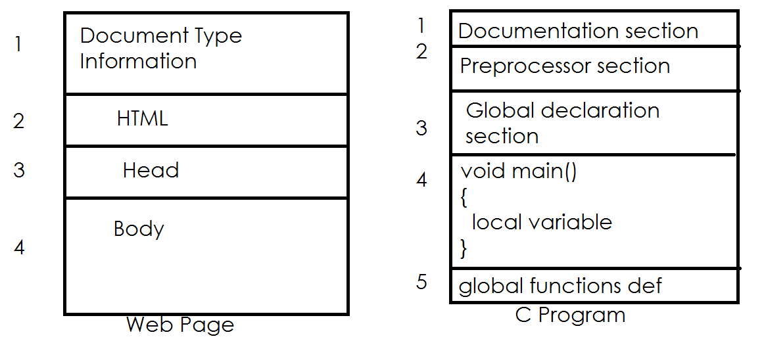

1. Document type information

**<!DOCTYPE>**

this tag tells the browser which version of HTML is used to develop web page or web document.

<!DOCTYPE HTML>

This tag must be first statement/first tag within html page

This tells the browser it is which type of document

This tells the programmer which type of HTML version is used for building webpage

! is used to represent comment

In HTML comments are represented using,

<!--- >

Document type is comment, which is not parsed by HTML parser.

**<html>**

<html> is a root tag of HTML document/web page

<html> is having begining and ending <html>....</html>

every tag is having properties or attributes, these attributes defines the state or behaviour of tag

**Syntax:**

<html>

</html>

The content of html is divided into two parts.

1. Head section
2. Body section

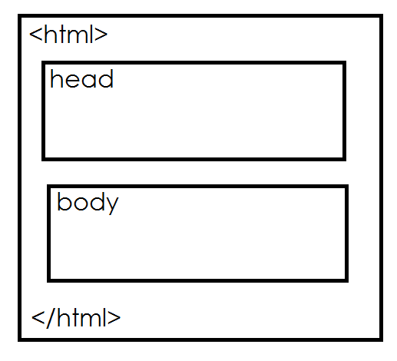

**Head section or Header Section**

Header section is defined using <head> tag.